ULTRASONICS
- Introduction to Ultrasonic Waves,
- Production of Ultrasonic Waves
- Magnetostriction Method,
- Ultrasonic Pulse-Echo Testing Method,
- Engineering Applications of Ultrasonics.
Ultrasonic waves are sound waves that have frequencies above the human audible range, typically exceeding 20 kHz. These waves are characterized by their ability to propagate through various materials, making them useful in a wide range of applications, including medical imaging (like ultrasound scans), industrial non-destructive testing (to detect flaws in materials), cleaning, and even pest control. Ultrasonic waves can travel through solids, liquids, and gases, and their behavior can be affected by the medium through which they pass, allowing for detailed analysis and manipulation in various fields.

Properties of Ultrasonics
1. Ultrasonic waves are longitudinal in nature.
2. They are highly energetic.
3. Like sound waves ultrasonic waves undergo reflection and refraction. They can also be absorbed.
4. When ultrasonic waves are passed through liquid, it produces stationary wave pattern and the liquid behave as an acoustic grating.
5. Ultrasonic waves can travel through longer distance.
6. The speed of propagation of ultrasonic wave increases with increase in frequency.
7. They produce cavitation effects in liquids.
8. Due to the small wavelength ultrasonic show very negligible diffraction.
9. Penetrates solids, liquids, and gases but with varying attenuation based on frequency.
10. The speed and attenuation of ultrasonic waves change with temperature and material properties.
Production of Ultrasonic Waves - Magnetostriction Method,
Magnetostriction effect: When a ferromagnetic rod like iron or nickel is placed in a magnetic field parallel to its length, the rod experiences a small change in its length. This is called magnetostriction effect. The change in length (increase or decrease) produced in the rod depends upon the strength of the magnetic field, the nature of the materials and is independent of the direction of the magnetic field applied.
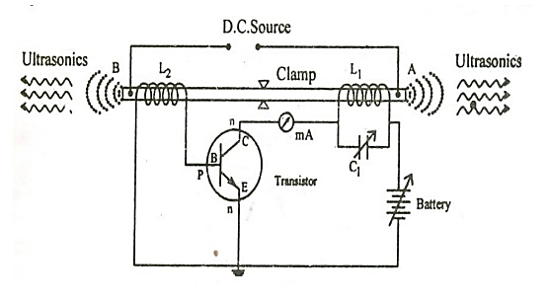
Construction: The experimental arrangement is shown in Figure. AB is a rod of ferromagnetic materials like iron or nickel. The rod is clamped in the middle. The alternating magnetic field is generated by electronic oscillator. The coil L1 wound on the right hand portion of the rod along with a variable capacitor C1. This forms the resonant circuit of the collector tuned oscillator. The frequency of oscillator is controlled by the variable capacitor. The coil L2 wound on the left hand portion of the rod is connected to the base circuit. The coil L2 acts as feed –back loop.
Working: When High Tension (H.T) battery is switched on, the collector circuit oscillates with a frequency, f= $\frac{1}{2 \sqrt{L1C1}}$
This alternating current flowing through the coil L1 produces an alternating magnetic field along the length of the rod. The result is that the rod starts vibrating due to magnetostrictive effect.
The frequency of vibration of the rod is given by f = $\frac{1}{2l}\sqrt{\frac{Y}{}}$
where l = length of the rod
Y = Young’s modulus of the rod material and ρ = density of rod material.
The capacitor C is adjusted so that the frequency of the oscillatory circuit is equal to natural frequency of the rod and thus resonance takes place.Now the rod vibrates longitudinally with maximum amplitude and generates ultrasonic waves of high frequency from its ends.
Advanatages: The design of this oscillator is very simple and its production cost is low.
At low ultrasonic frequencies, the large power output can be produced without the risk of damage of the oscillatory circuit.
Disadvantages: It has low upper frequency limit and cannot generate ultrasonic frequency above 3000 kHz (ie. 3MHz).
The frequency of oscillations depends on temperature. There will be losses of energy due to hysteresis and eddy current.

PULSE-ECHO Method for detection of Ultrasonic waves
In pulse-echo (or reflection) mode, the transducer performs both the sending and the receiving of the pulsed waves as the "sound" is reflected back to the device. Reflected ultrasound comes from an interface, such as the back wall of the object or from an imperfection within the object. The diagnostic machine displays these results in the form of a signal with an amplitude representing the intensity of the reflection and the distance, representing the arrival time of the reflection.
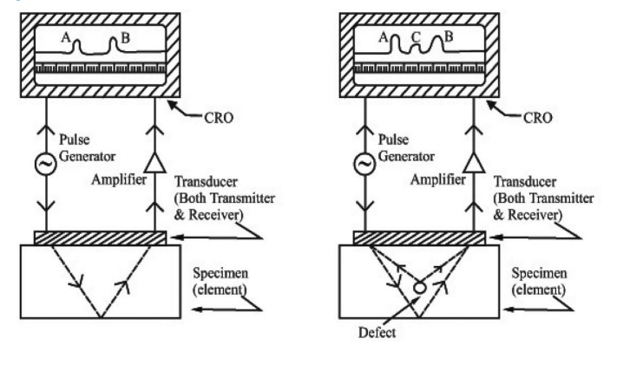
A typical pulse-echo UT inspection system consists of several functional units, such as ultrasonic frequency generator and a cathode ray oscilloscope (CRO),transmitting transducer(A), receiving transducer(B) and an amplifier.
The transducer is typically separated from the test object by a couplant (such as oil) or by water. Driven by the high frequency generator G, the transducer A generates high frequency ultrasonic energy. An ultrasound transducer connected to a diagnostic machine is passed over the object being inspected. The sound energy is introduced and propagates through the materials in the form of waves. When there is a discontinuity (such as a crack) in the wave path, part of the energy will be reflected back from the flaw surface. The reflected wave signal is transformed into an electrical signal by the transducer B and is displayed on a screen. Knowing the velocity of the waves, travel time can be directly related to the distance that the signal traveled. From the signal, information about the reflector location, size, orientation and other features can sometimes be gained.
Advantages
1. High penetrating power, which allows the detection of flaws deep in the part.
2. High sensitivity, permitting the detection of extremely small flaws.
3. Only one surface needs to be accessible.
4. Greater accuracy than other nondestructive methods in determining the depth of internal flaws and the thickness of parts with parallel surfaces.
5. Some capability of estimating the size, orientation, shape and nature of defects.
6. Non hazardous to operations or to nearby personnel and has no effect on equipment and materials in the vicinity.
7. Capable of portable or highly automated operation.
Disadvantages
1. Manual operation requires careful attention by experienced technicians.
2. Extensive technical knowledge is required for the development of inspection procedures.
3. Parts those are rough, irregular in shape, very small or thin, or not homogeneous are difficult to inspect.
4. Surface must be prepared by cleaning and removing loose scale, paint, etc., although paint that is properly bonded to a surface need not be removed.
5. Couplants are needed to provide effective transfer of ultrasonic wave energy between transducers and parts being inspected unless a non-contact technique is used. Non-contact techniques include Laser and Electro Magnetic Acoustic Transducers (EMAT).
6. Inspected items must be water resistant, when using water based couplants that do not contain rust inhibitors

Applications of Ultrasonics:
Ultrasonic technology has a wide range of applications across various industries due to its unique properties. Below are some additional applications of ultrasonics beyond medical imaging and non-destructive testing:
- Medical Imaging (Ultrasound): Used to create images of internal body structures like organs, tissues, and fetuses.
- Non-Destructive Testing (NDT): Detects internal flaws in materials without damaging them, widely used in industries like aerospace and construction.
- Ultrasonic Cleaning: Cleans delicate items like jewelry, medical instruments, and electronics by using cavitation in a liquid.
- Ultrasonic Welding: Joins plastics or metals without adhesives or heat, used in automotive, electronics, and medical device manufacturing.
- Sonar (Sound Navigation and Ranging): Detects underwater objects, used in submarines, fishing, and oceanography.
- Ultrasonic Flow Measurement: Measures fluid flow rates in pipes without needing to insert sensors.
- Ultrasonic Lithotripsy: Breaks kidney stones into smaller pieces for easier passage.
- Ultrasonic Sensors: Used for distance measurement, object detection, and automation in robotics and vehicles.
- Sonochemistry: Enhances chemical reactions, used in processes like emulsification and polymerization.

